**P1 E: Perform what-if analysis using Goal Seek to determine input values for desired output**

1. Here is the data set calculate the average of the scores

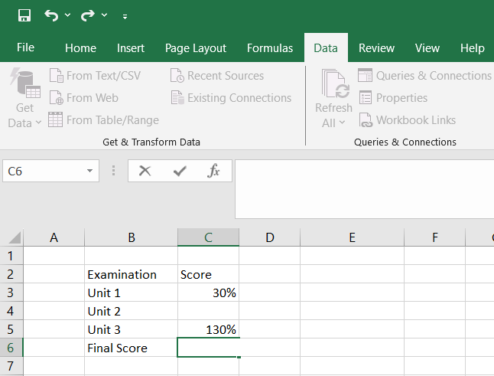

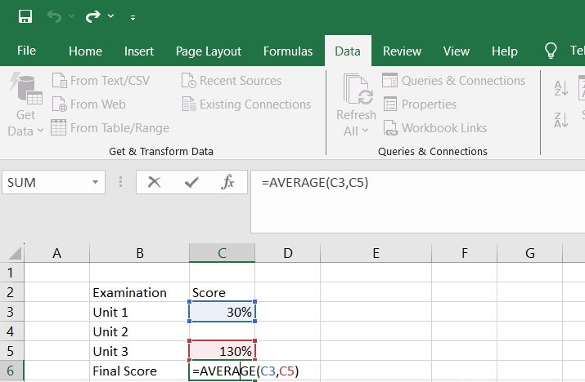

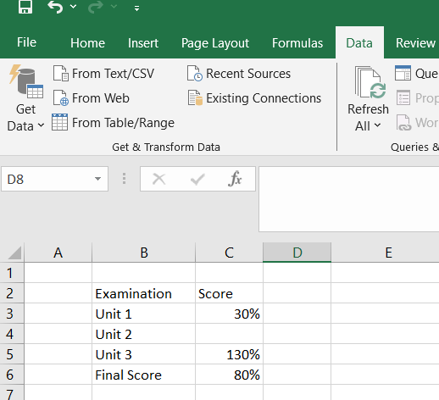

Go to “What-if Analysis” in Data Menu

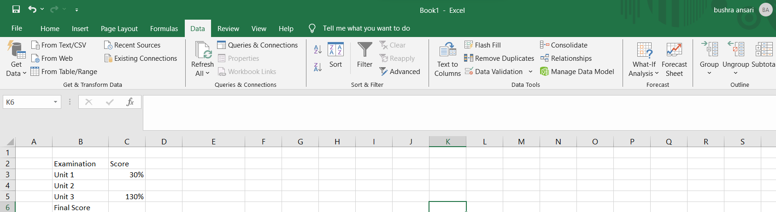



Select “Goal Seek”

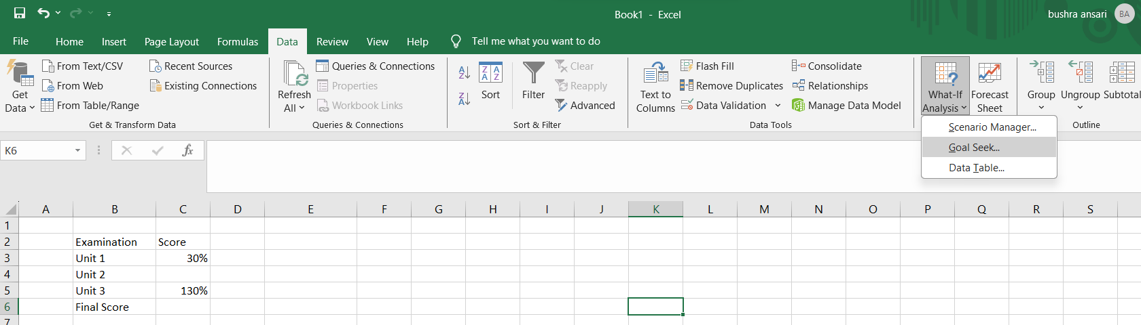

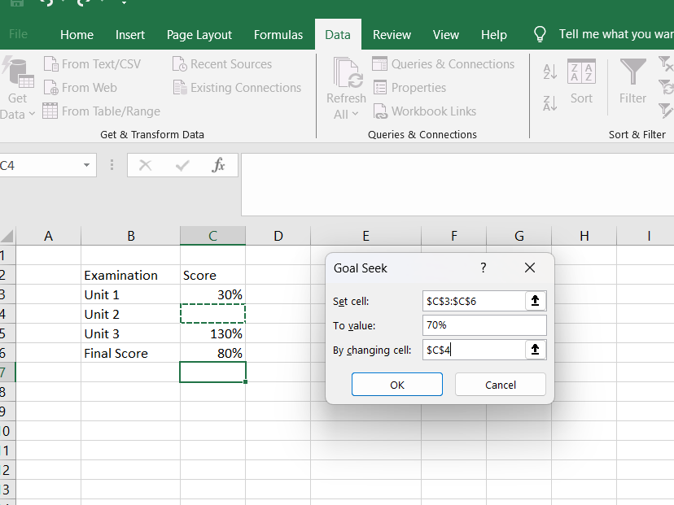

Here is the Calculated grade for unit 2

